**Community learning centre – June 2024**

**Summer Camp Report**

**Overview:**

A summer camp was organized for village children during their vacation in primary schools. Various teaching methods and games were employed to engage the children, who participated with great enthusiasm. The camp aimed to enhance their skills and provide a fun, educational experience.

**Activity Schedule:**

* **01/06/2024 (Saturday):** Map Making
* **02/06/2024 (Sunday):** No activities
* **03/06/2024 (Monday):** Handwriting Skill
* **04/06/2024 (Tuesday):** Anulekhan (Creative Writing)
* **05/06/2024 (Wednesday):** Yoga
* **06/06/2024 (Thursday):** Rangoli Making
* **07/06/2024 (Friday):** Mehendi and Drawing
* **08/06/2024 (Saturday):** Sports
* **09/06/2024 (Sunday):** No activities
* **10/06/2024 (Monday):** Art & Craft
* **11/06/2024 (Tuesday):** Home Visit
* **12/06/2024 (Wednesday):** Home Visit
* **13/06/2024 (Thursday):** Experience Sharing

**Yoga Day Celebration**

Yoga Day was celebrated at the Community Learning Centres in Tragadi, Gundiyali, Talwana, Bidada, and Mota Kandagara. The event was covered by Sandesh News. Participants, including children, practiced Pranayama and various asanas. Information on the benefits of different asanas was provided, and children were encouraged to incorporate yoga into their daily routine. 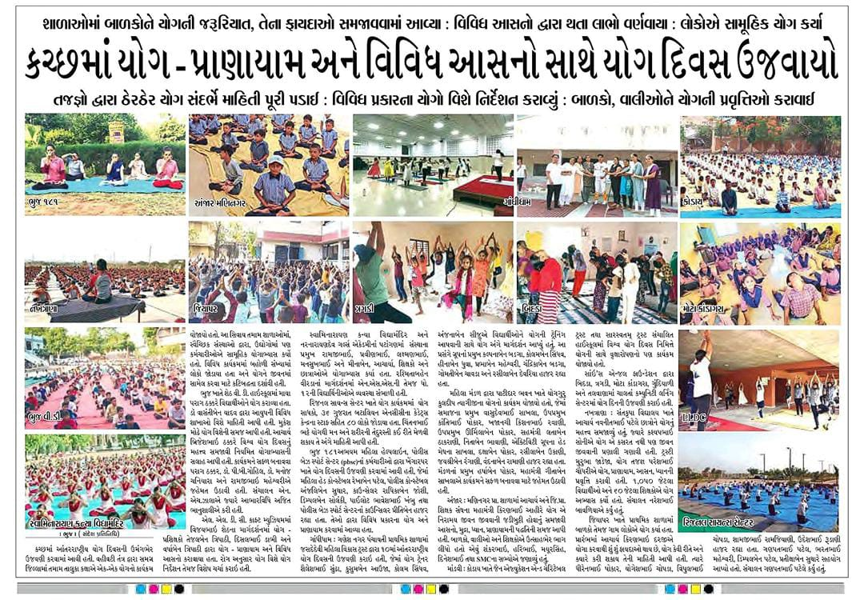

**Environmental Awareness Activities**

**Save the Environment (Climate Change):** Children created aviaries out of cardboard and made drinking vessels for birds. Working in groups, they used bottles to make water containers, promoting environmental conservation and wildlife support.

**Save the Water:** To raise awareness about water conservation, children participated in a drama highlighting the importance of saving water. Through this activity, they demonstrated that "water is life" and emphasized the need to prevent water wastage.

These activities aimed to foster a sense of responsibility towards the environment and community among the children, while also enhancing their creative, physical, and cognitive skills. The summer camp and special events were successful in providing a holistic educational experience outside the regular classroom environment.